1. In-Built server for Jenkins is Winstone.
2. We want to configure tomcat or some other servlet container.
3. Why?
   1. Maybe you have already tomcat installed and some app is running on it and you want to deploy Jenkins in the same tomcat as we know more than one app can be deployed on same server.
4. 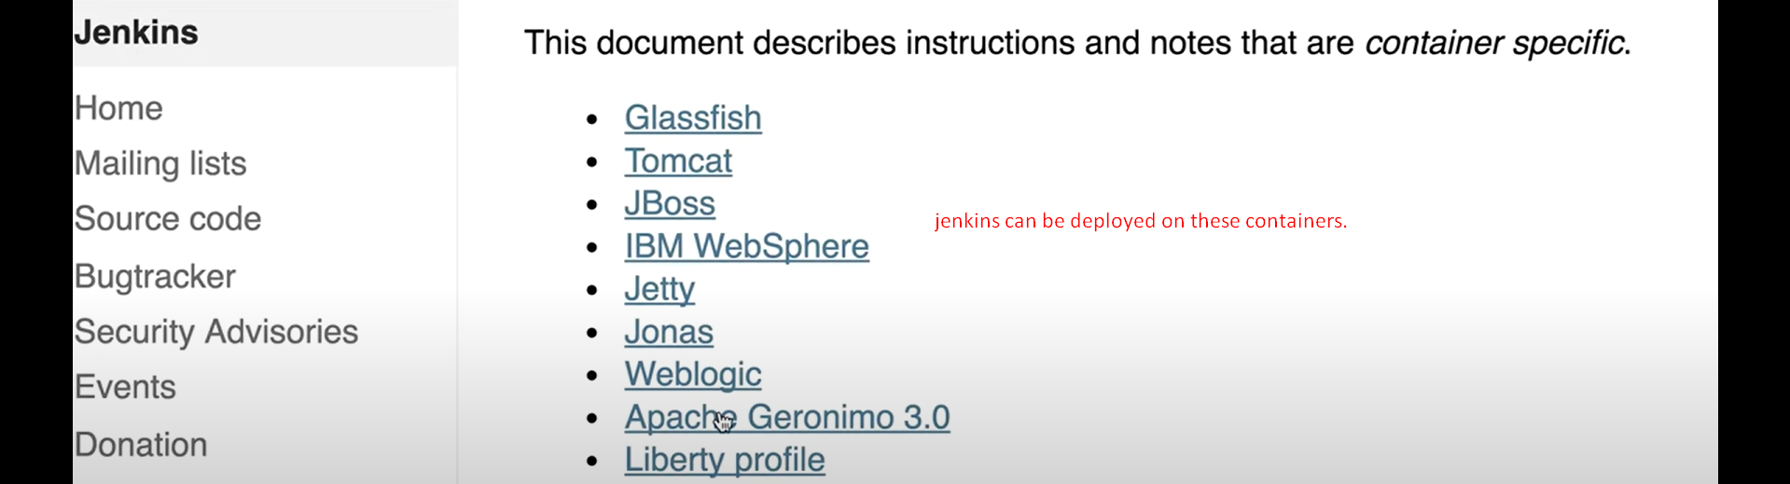
5. 
6. 